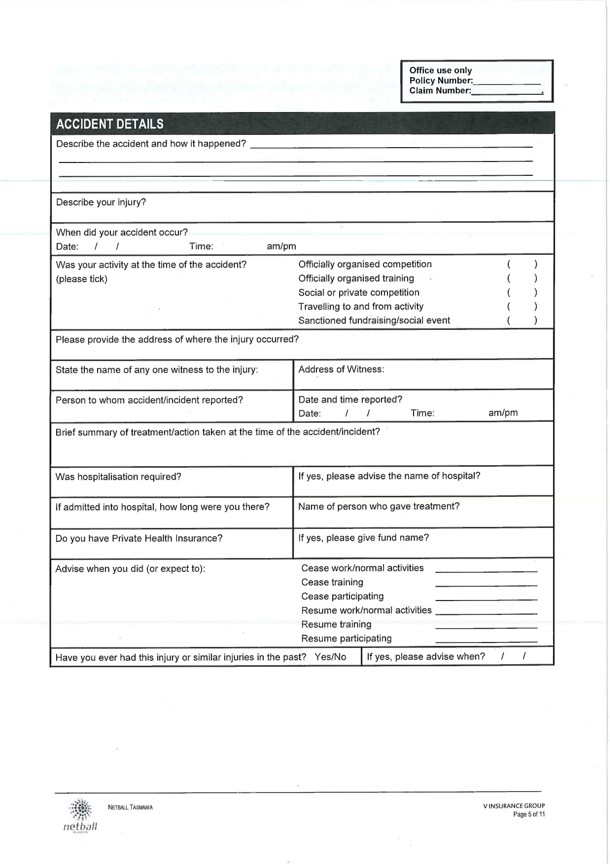

**This form is to be used to -**

* **notify the Club** of your injury – **please email to** [**support@kingstonblues.org.au**](mailto:support@kingstonblues.org.au)
* to use in support of any insurance claim you may need to lodge through Netball Tasmania insurance providers.

How to make an Insurance Claim –

Go to Web Pages –

<http://www.kingstonblues.org.au> OR

<http://tas.netball.com.au> policies & insurance OR

[**http://www.willisnetball.com/**](http://www.willisnetball.com/) **- this is the direct web page for insurance provider see below details from this page.**

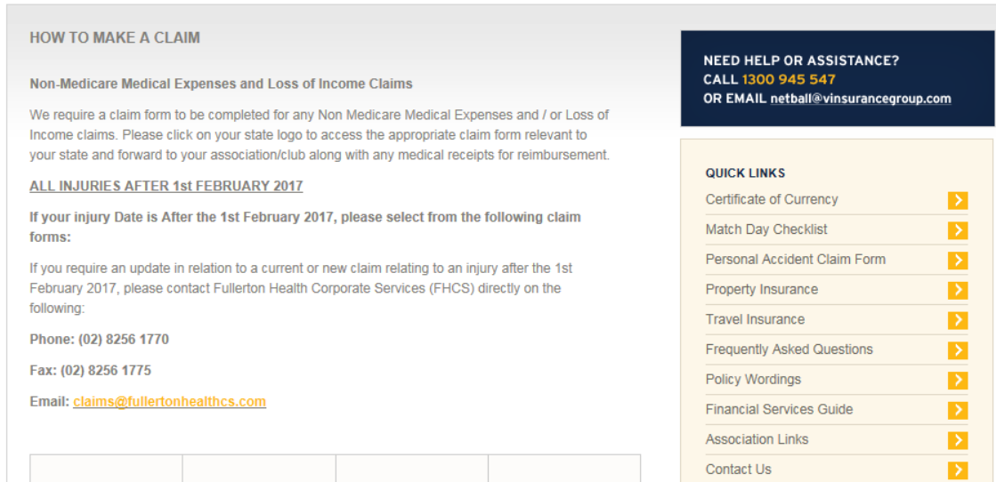

**The**

**following**

**information**

**is**

**required**

**for**

**Netball**

**Tasmania**

**research**

**to**

**assist**

**with**

**Risk**

**Management,**

**answering**

**these**

**questions**

**will**

**not**

**affect**

**vour**

**claim**

Where

did

your

injury

occur?

(

please

tick)

Indoor

(

)

Outdoor

(

)

Surface

at

point

of

injury?

(

please

tick)

Timber

(

)

Synthetic

(

)

Concrete

/

Asphalt

(

)

Other,

please

advise

(

)

Weather

conditions?

(

please

tick)

Fine

(

)

Rain

(

)

Showers

(

)

Extreme

Heat

(

)

Extreme

Cold

(

)

Surface

Conditions?

(

please

tick)

Wet

(

)

Dry

(

)

Other,

please

advise

(

)

Quarter/half

injured?

(

please

tick)

1

s

t

Quarter

(

)

2

n

d

Quarter

(

)

3

r

d

Quarter

(

)

4

t

h

Quarter

(

)

Not

applicable

(

)

V;VI"KV.

NETBALL

TASMANIA

*netball*

V

INSURANCE

GROUP

Page

6

of

11

